Task 2
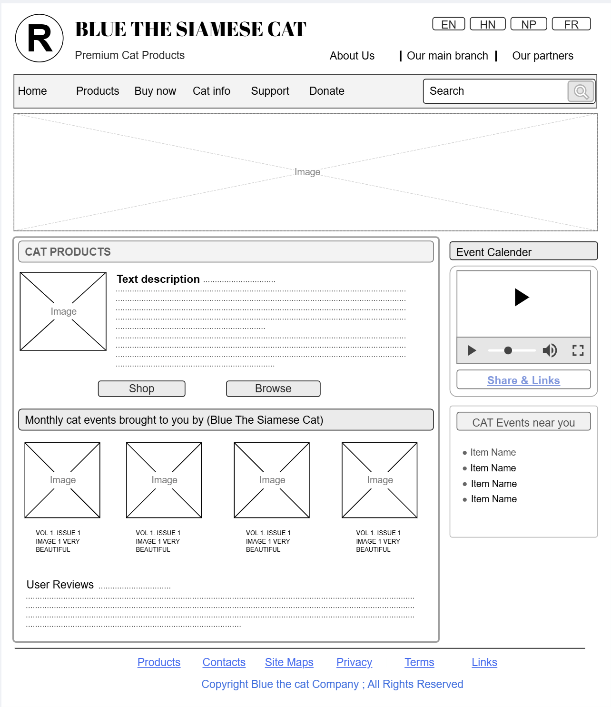

https://app.moqups.com/UTkb10yV6fHDUWNFCvhSL7oRb1ZTyZNx/view/page/ad64222d5

Task 3
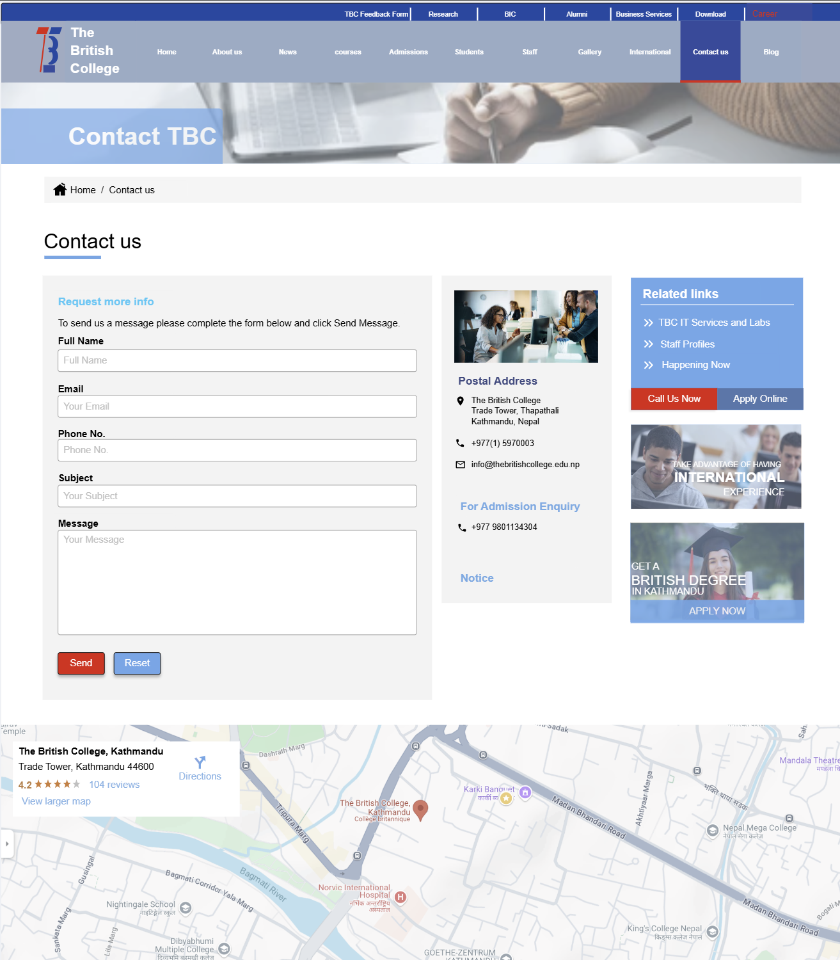

https://app.moqups.com/UTkb10yV6fHDUWNFCvhSL7oRb1ZTyZNx/view/page/a057a4431

